AI-Powered Smart Complaint Management System with Sentiment Analysis

A Project Report
Submitted
In Partial fulfilment
for the award of the Degree of Bachelor of Technology
In Department of Computer Science and Engineering



Guide:
Project Coordinator: Dr Yashpal Singh
Project Supervisor: Mr. Ddhruv Arora

Submitted by:
Aman Pareek-(AUR2221019) Gaurav Kumar-(AUR2221220) Manas Jain-(AUR2221159)
Sandeep Choudhary-(AUR2221169) Abhishek Singh -(AUR2221224)

Department of Computer Science and Engineering Amity School of Engineering & Technology
Amity University Rajasthan, Jaipur November 2025

CANDIDATE’S DECLARATION
I hereby declare that the project entitled “AI-Powered Smart Complaint Management System with Sentiment Analysis” submitted for the B.Tech(CSE) degree is my original work and the project has not formed the basis for the award of any other degree, diploma fellowship or any other similar titles

Place: Amity University Rajasthan
Date:

Signature of Student:
Aman Pareek-
Gaurav Kumar-
Manas Jain-
Sandeep Choudhary-
Abhishek Singh Chouhan-

TABLE OF CONTENTS

Table Of Figures 4
Abstract 5
Acknowledgement 6
Chapter 1: Introduction 7-16
  - Problem Defination 7
  - Problem Overview 8
  - hardware Specification 8-10
  - Software Specification 10-11
    - Scope 11-14
    - Limitation 15-16
Chapter 2: Literature Survey 17-25
  - Existing System 17-18
  - Proposed System 18-21
  - Feasibility study 21-25
Chapter 3: Results 26-30
Conclusion 31
References 32

TABLE OF FIGURES

Figure 3.1.Login Page 27
Figure 3.2.Admin Dashboard 28
Figure 3.3. Analytics and Report 28
Figure 3.4. Document Management 29
Figure 3.5. Employee Management 29
Figure 3.6. Employee Portal 30

ABSTRACT
The AI-Powered Smart Complaint Management System with Sentiment Analysis is designed to modernize and streamline the traditional grievance-handling process within academic institutions. Existing complaint systems are often manual, slow, and lack transparency, making it difficult for students to track the status of their issues and for administrators to prioritize and respond efficiently. To address these challenges, the proposed system integrates automation, artificial intelligence, and a multi-role web architecture to create an intelligent, user-friendly, and efficient complaint resolution platform.
The system enables students to securely submit complaints online, which are then processed through a sentiment analysis model to extract emotional tone, polarity, urgency level, and category of the issue. This AI-driven prioritization helps administrators identify critical complaints more quickly and allocate actions effectively. Built using Java Spring Boot (backend), React with TypeScript (frontend), and MySQL (database), the platform also includes role-based authentication using JWT, dashboards for students and administrators, real-time status updates, graphical analytics, and automated notifications.
By combining modern web technologies with natural language processing, the system improves transparency, enhances communication, and reduces response time in complaint redressal. The project demonstrates how AI and full-stack development can be applied to create a smarter, faster, and more reliable institutional support system.

Acknowledgement
I would like to express my sincere gratitude to all those who supported and guided me throughout the development of this project, “AI-Powered Smart Complaint Management System with Sentiment Analysis.”
First and foremost, I extend my heartfelt thanks to my project guide, whose continuous encouragement, expert insights, and valuable suggestions played a crucial role in shaping the direction of this project. Their guidance helped me understand the core concepts, refine the system’s architecture, and overcome technical challenges during implementation.
I am also grateful to the faculty members of the Department of Computer Science and Engineering, Amity University Rajasthan, for providing a strong academic foundation and an environment that encouraged innovation and practical learning.
I would like to thank my friends and classmates for their constructive feedback, collaboration, and motivation throughout the development process. Their support helped enhance the quality and functionality of the system.
Finally, I express my deepest appreciation to my family for their constant encouragement, patience, and belief in my abilities during this entire journey.
This project would not have been possible without the collective support and guidance of all the individuals, and I extend my sincere thanks to each one of them

Chapter 1

Introduction

Problem Definition
In most academic institutions, the complaint handling process is still manual, slow, and poorly organized. Students typically submit complaints through handwritten applications, emails, or verbal communication to faculty or administrative staff. This leads to several issues such as delays, lost complaints, lack of proper tracking, and no systematic way to determine which issues require urgent attention. Administrators also struggle to categorize grievances, maintain records, and respond efficiently due to the absence of a structured platform.
Additionally, all complaints are treated equally, regardless of their seriousness or emotional intensity, making it difficult to prioritize issues that may require immediate action. Without intelligent analysis, institutions face challenges in recognizing patterns, monitoring response times, or improving service quality. The absence of a centralized digital platform, automation, and intelligent classification results in miscommunication, inefficiency, and low student satisfaction.
Therefore, there is a need for a smart, automated, and AI-enhanced complaint management system that enables students to submit complaints easily and allows administrators to track, analyze, and resolve grievances efficiently with better prioritization.

1.2 Problem Overview

The traditional complaint redressal system in educational institutions suffers from several limitations, including manual handling, lack of transparency, and slow response times. Students often do not receive timely updates regarding their complaints, and administrators lack tools to manage large volumes of grievances effectively. There is no unified platform where students can submit complaints and track their status, and there is no automated method for administrators to categorize complaints based on severity or urgency.

The traditional complaint redressal system in educational institutions suffers from several limitations, including manual handling, lack of transparency, and slow response times. Students often do not receive timely updates regarding their complaints, and administrators lack tools to manage large volumes of grievances effectively. There is no unified platform where students can submit complaints and track their status, and there is no automated method for administrators to categorize complaints based on severity or urgency.

The traditional complaint redressal system in educational institutions suffers from several limitations, including manual handling, lack of transparency, and slow response times. Students often do not receive timely updates regarding their complaints, and administrators lack tools to manage large volumes of grievances effectively. There is no unified platform where students can submit complaints and track their status, and there is no automated method for administrators to categorize complaints based on severity or urgency.

Furthermore, institutions do not utilize emotional cues or behavioral signals from the complaint text, making it difficult to identify issues that need immediate administrative attention. Without sentiment analysis, complaints expressing frustration, anger, or critical concerns are not prioritized correctly, resulting in delayed responses and dissatisfaction.

The proposed AI-Powered Smart Complaint Management System addresses these challenges by providing a centralized web application where students can submit complaints digitally, and administrators can manage and resolve them through structured workflows. The incorporation of sentiment analysis helps automatically identify the emotional intensity and urgency of each complaint, enabling better prioritization. Dashboards, analytics, secure authentication, and real-time status updates ensure transparency, efficiency, and improved communication between students and administration.

Hardware Specification
Since the Smart Complaint Management System is a web-based application built using Java Spring Boot and React, the hardware requirements are divided into Server-Side and Client-Side.
Server-Side Hardware Requirements (for hosting and deployment)

Client-Side Hardware Requirements (for end users accessing the platform)

Server-Side Hardware Specifications

To host the backend (Spring Boot), database (MySQL), and sentiment analysis engine, the system requires reliable server-side hardware. The following baseline configuration is recommended for smooth operation.

Application Server

Component Specification
Processor (CPU) Quad-Core Processor (Intel i5/i7) Memory (RAM) 16 GB – 64 GB DDR4/DDR5 Storage (SSD) 256 GB – 1 TB NVMe SSD
Network 1–10 Gbps Network Interface
OS Windows Server / Ubuntu Server / Debian
Deployment Localhost, On-Premises Server, or Cloud VM

Database Server

Component Specification CPU Quad Core
RAM 8GB – 16 GB (for heavy queries, reporting, analytics) Storage 100 GB – 1TB SSD (for complaint logs & backup)
Performance Database indexing, caching, backup schedules

File Storage Server

The database server manages users, complaint records, sentiment scores, logs, and history. Efficient indexing is required for quick search and filtering of records.

Client-Side Hardware Specifications

End users include:
✔ Students
✔ Administrators

Desktop / Laptop Requirements

Component Minimum Recommended
Processor Dual-Core CPU Intel i5 / Ryzen 5 or above
RAM 4 GB 8 GB or higher
Storage Any modern HDD/SSD SSD preferred for faster performance.
Display 1366×768 Full HD (1920×1080)
Latest Chrome, Edge, or

Browser
Firefox
Auto-update enabled.

10–20 Mbps broadband for video calls & real-time

Internet 5 Mbps
dashboards

Software Specification

Server-Side Software Specifications

  - Operating System

- Windows Server

Backend Technologies

- JDK 17 – LTS Recommended
- Spring Boot Framework– For building scalable APIs.
- Rest API Architecture – For communication.

Database Requirements

MySQL 8.0 (Primary choice for flexible schema & scalability)

Security Tools

SSL/TLS Certificates

JWT & OAuth 2.0 Authentication

1. Client -Side Software Specifications

  - Browsers Supported Google Chrome (Latest version) Microsoft Edge
Mozilla Firefox

Safari (for macOS & iOS users)

Device Operating Systems

Windows 10/11 macOS

Frontend Technologies

React.js – UI framework Redux – State management Tailwind CSS – UI styling
Axios / Fetch API – API communication

Scope

The scope of this project includes the design, development, implementation, and deployment of an AI-Powered Smart Complaint Management System that centralizes complaint submission, tracking, categorization, sentiment-based prioritization, and automated workflow management within academic institutions. The system supports multiple user roles—Student and Admin—each with dedicated dashboards, permissions, and functionalities.

Functional Scope

1.1 User Management
    - Secure authentication for Students and Admins

    - JWT-based login, logout, and session management

    - Role-Based Access Control (RBAC)

    - User profile management and password update

Complaint Submission & Tracking

    - Students can submit complaints through an online form.

    - Ability to upload text-based descriptions.

    - Automatic complaint registration with unique ID

    - Students can track complaint status (Pending, In Progress, Resolved)

    - View history of past complaints

Sentiment Analysis Module

    - NLP-powered sentiment classifier (Positive, Neutral, Negative)

    - Automatic priority assignment based on sentiment.

    - Complaint tagging using tone (anger, frustration, sadness, etc.)

    - Helps admin prioritize urgent complaints.

Admin Dashboard & Complaint Management

    - View all complaints with filters (Date, Category, Priority, Sentiment)

    - Change complaint status (Pending → In Progress → Resolved)

    - Add remarks and resolution notes.

    - View student details and complaint history

Notifications & Alerts

    - Complaint submission

    - Status updates

    - Admin responses

    - Email/SMS notifications (optional future module)

Communication & Collaboration

    - Built-in chat and group messaging

    - Video calling (WebRTC)

    - File sharing with secure access

    - Notifications, reminders, and alerts

Communication & Collaboration

    - Built-in chat and group messaging

    - Video calling (WebRTC)

    - File sharing with secure access

    - Notifications, reminders, and alerts

Reporting & Analytics

    - Graphical representation of total complaints

    - Sentiment distribution charts

    - Category-wise complaint analytics

    - Daily/weekly/monthly statistics

Data Storage & Management

    - MySQL-based structured data storage

    - Secure database for users, complaints, sentiments, and logs

    - Backup/restore support

Non-Functional Scope

  - Performance

    - Real-time dash updates for Admin

    - Fast page load using optimized APIs and caching

Security

    - JWT – based authentication

    - Encrypted password storage using hashing

    - Secure complaint and student data handling

Scalability

    - Backend designed to support increasing number of users and complaints

    - Scope to add more roles like HOD, Registrar, Faculty, etc.

Reliability

    - Consistent application behavior across devices and browsers

    - Ensures complaint record integrity

Usability

    - Clean, simplified UI with React + Tailwind CSS

    - Easy complaint form with clear instructions

    - Accessible to non-technical users

Out-of-Scope Items

The following items are outside the current project scope (optional for future release):

- AI-based predictive analytics

- Payroll tax filings for all global regions

- Advanced HR chatbots

- Integration with third-party ERP tools

- Hardware biometric devices integration

Deliverables

- Fully functional multi-role SaaS web platform

- Admin dashboard and employee/client portals

- Cloud deployment with monitoring setup

- Documentation (User guide, API docs, architecture docs)

- Testing reports (Unit, Integration, Load)

Limitation
Although the AI-Powered Smart Complaint Management System aims to deliver an intelligent, efficient, and centralized platform for handling complaints within educational institutions, there are certain limitations due to technical, operational, and practical constraints. These limitations are outlined below:

Dependency on Stable Internet Connectivity

As the system is fully web-based, its functionalities such as complaint submission, sentiment analysis, admin dashboard updates, and status tracking require a stable internet connection. Poor or unstable internet on the user side may affect:
  - Real-time updates

  - Response time

  - Monitoring accuracy

  - Application performance

Limited Offline Functionality

The system primarily functions online; offline access is minimal:

  - Complaints cannot be submitted offline

  - Status updates require internet

  - Sentiment analysis and admin actions cannot run without server connectivity

Resource Usage for AI Processing

Sentiment analysis and text-processing operations may consume additional computational resources, especially when handling:

  - Large complaint texts

  - Multiple requests simultaneously

  - Real-time analysis on the admin side

This may slow down performance on low-end systems.

Privacy & Data Protection Concerns

While the system follows standard security practices, certain limitations still exist::

  - Sensitive student data is stored digitally, requiring strict access control

  - Institutions must follow policies for responsible data handling

  - Sentiment classification results must be ethically managed to avoid bias

The system cannot override institutional privacy laws or regulations.

Scalability Depends on Hosting Infrastructure

Although the system is scalable by design, actual scalability depends on deployment:

  - Shared hosting environments may limit performance

  - Increased user load may require upgraded server resources

  - Cloud deployment adds recurring costs

  - Small institutions may prefer minimal scaling initially to reduce costs.

No Direct Integration With Third-Party Systems

The current version does not include integrations such as::

  - SMS gateways

  - Institutional ERP systems

  - Email automation APIs

  - Biometric attendance or notification systems

These can be added in future releases if required..

Chapter-2

Literature Survey

Existing System
In most educational institutions, the current complaint management systems are still based on manual or semi-digital processes. These systems rely heavily on physical forms, emails, written applications, or basic online forms that do not provide automation, prioritization, or real-time tracking. Several limitations exist in these traditional systems:

Lack of Centralized Platform

Students submit complaints through scattered channels—emails, handwritten letters, personal visits, or informal communication—leading to lost records, inconsistencies, and delayed processing.

No Real-Time Tracking or Transparency

Students rarely receive updates about the status of their complaints. They must repeatedly approach administrative offices for progress checks. This creates frustration and reduces trust in the system.

Manual Categorization and Prioritization

Administrators manually read and interpret the complaint text. Without automation, identifying critical issues is slow and error-prone, especially when complaint volume is high.

Inability to Analyze Sentiment or Emotional Tone

Traditional systems treat all complaints equally, without understanding urgency or emotional intensity such as anger, frustration, or distress. This results in poor prioritization.

Poor Documentation and Record-Keeping

Manual systems often lack a structured database, making it difficult to:. Retrieve historical complaint data, Generate insights, Monitor repeated issues, Measure institution performance.

Limited Scalability and High Administrative Load

As institutions grow, the volume of complaints increases, but manual systems do not scale. Administrators face operational inefficiencies and delayed response times

No Analytical or Reporting Tools

Traditional systems provide no graphical analytics, sentiment trends, or category-wise summaries—essential for decision-making and improving campus services.
Overall, existing systems fail to deliver automation, intelligence, transparency, and efficiency, making them unsuitable for modern institutional needs.

Proposed System
The AI-Powered Smart Complaint Management System with Sentiment Analysis aims to resolve the limitations of traditional systems by providing an intelligent, centralized, and automated complaint management platform. The system leverages Natural Language Processing (NLP), modern web technologies, and structured workflows to enhance complaint handling efficiency.

Unified Digital Platform

The system offers a centralized portal where students can submit complaints and track them in real time. Administrators can manage, categorize, and resolve complaints through a structured dashboard.

AI-Based Sentiment Analysis

The major innovation in the proposed system is the integration of NLP techniques to identify the emotional tone of each complaint. The system automatically determines:

Sentiment polarity (positive, neutral, negative)

Emotional strength

Urgency score

Priority level

This allows administrators to address critical complaints first, improving response quality and student satisfaction.

Structured Complaint Lifecycle

The system introduces an automated complaint lifecycle:

  - Complaint Submitted

  - Sentiment Analysis Performed

  - Priority Assigned

  - Admin Reviews and Responds

  - Complaint Status Updated (Pending → In Progress → Resolved)

This ensures consistency, transparency, and efficiency..

Real-Time Notifications & Updates

Students receive instant system updates when::

  - A complaint is filed
  - Status is updated
  - Admin responds

This eliminates guesswork and improves transparency.

Analytics and Reporting

The system generates:

  - Category-wise complaint reports

  - Sentiment distribution charts

  - Daily/weekly/monthly complaint summaries

  - Priority-wise breakdown

These insights help institutions identify common issues and improve administrative efficiency.

Secure and Scalable Architecture

The system uses::

  - Spring Boot (Backend) for reliability and scalability

  - React (Frontend) for modern UI/UX

  - MySQL for structured data storage

  - JWT for secure authentication

Feasibility Study
The feasibility study evaluates whether the system can be efficiently designed, implemented, deployed, and used in real-world institutional environments.

Technical Feasibility

This section evaluates whether the required technologies, tools, and infrastructure are appropriate and sufficient to build the AI-Powered Smart Complaint Management System with Sentiment Analysis. The project uses modern, reliable, and open-source technologies, ensuring strong technical feasibility.,

Technology Availability

The system uses widely supported technologies such as:

    - Java Spring Boot 3.x – Backend framework for building secure REST APIs

    - React with TypeScript – Responsive and interactive frontend interface

    - MySQL/MariaDB – Relational database management system

    - JWT Authentication – Secure user login and session handling

    - NLP-based Sentiment Analysis Tools – For complaint priority classification

All selected technologies are stable, open-source, platform-independent, and have large community support. This ensures smooth development, maintenance, and future enhancements..

System Scalability

The system is designed with scalability in mind to support:
    - A growing number of students

    - Increasing volume of complaints

    - Additional admin users and departments

This ensures that the system can adapt to increased workload without compromising performance or reliability.

Integration Capability

The system supports smooth integration with external services and future extensions such as

    - Email/SMS notification APIs

    - Institutional ERP/Student Management Systems

    - Chatbot modules for automated student communication

    - AI-based classification or recommendation engines

A modular backend architecture using Spring Boot allows easy addition of new services and third-party integration with minimal changes to the existing code. This makes the system future ready and adaptable to institutional requirements.

Operational Feasibility

Operational feasibility evaluates whether the proposed system will function effectively in a real institutional environment and whether users (students and administrators) can adopt the system smoothly. The AI-Powered Smart Complaint Management System is designed to improve day-to-day complaint handling operations, reduce manual workload, and enhance communication. The system demonstrates strong operational feasibility based on the following factors:

User Adoption

The system is highly user-friendly and designed for easy adoption by:

    - Students, who can submit complaints through a simple, guided interface

    - Admins, who can access a centralized dashboard to manage, review, and monitor complaints

The intuitive design, clean UI, and minimal learning curve encourage smooth onboarding for all users. The sentiment analysis module works automatically in the background, requiring no additional technical knowledge from the user..

Process Improvement

The system significantly enhances traditional complaint-handling workflows through:

    - Automated complaint registration and categorization

    - Sentiment-based priority assignment

    - Real-time status updates and notifications

    - Organized dashboards for quick viewing and actions

    - Structured complaint lifecycle management

These enhancements reduce manual intervention, minimize delays, and ensure more accurate prioritization of grievances. Administrators can handle complaints more efficiently, resulting in improved service quality..

Multi-portal Role Management
The system improves operational transparency through:
- A dedicated student dashboard to track the complaint status
- Admin remarks and resolution history
- Automatic status updates
21
This reduces the need for physical follow-ups, increases trust, and enhances user satisfaction.
2.4 Multi-role Functionality
The platform supports two key roles:
- Student Role – Complaint submission and tracking
- Admin Role – Complaint management, updates, and reporting
Role-Based Access Control (RBAC) ensures each user accesses only the features relevant to them. This makes administrative processes more secure and organized, aligning the system with real institutional workflow structures.
2.5 Reduced Administrative Burden
Automation reduces the workload of administrative staff by:
- Eliminating the need for manual record-keeping
- Reducing repetitive tasks
- Prioritizing urgent issues automatically
- Providing analytical insights for better decision-making
This leads to higher operational efficiency and quicker response cycles.
2.6 Real-time Monitoring and Reporting
The admin dashboard provides:
- Complaint statistics
- Priority distribution
- Sentiment analysis insights
- Category-wise graphs
These features help administrators identify recurring issues, analyze trends, and allocate resources more efficiently.
2.7 Ease of Maintenance and Training
- The system’s modular architecture simplifies updates and fixes
- Minimal training is needed for users
- Interface resembles modern web applications, making it easy to learn
- Documentation and help modules can be added for better onboarding
Overall, the system can be operated and maintained easily without requiring advanced technical skills.

Economic Feasibility

Economic feasibility examines whether the benefits offered by the AI-Powered Smart Complaint Management System outweigh the costs associated with its development, deployment, and maintenance. Since the system is built using modern, open-source technologies and does not require expensive hardware or licensed software, its 22

Cost of Development

The project primarily involves development efforts in the following areas:
- Backend development (Spring Boot APIs, sentiment module integration)
- Frontend development (React + TypeScript UI)
- Database setup (MySQL tables, indexing, query optimization)
- UI/UX design and layout
- Testing and bug fixing
- Deployment on local or cloud server
Because the system uses open-source tools such as:
- Java Spring Boot
- React & TypeScript
- MySQL
- Node.js
- Postman
- GitHub
there are no licensing fees involved. The overall development cost remains minimal, limited to:
- Developer time
- System resources
- Optional cloud hosting fees

Using open-source technologies and cloud pay-as-you-go models keeps costs manageable.

3.2 Deployment and Hosting Costs
Institutions have two deployment options:
A. Local Server Deployment (Low Cost)
- Utilize existing institutional servers.
- Minimal infrastructure cost No recurring fees
B. Cloud Deployment (Moderate Cost)
- Hosting on AWS / Azure / GCP
- Pay-as-you-use model
- Monthly costs depend on usage and traffic
- Easily scalable
Even in cloud environments, small-scale usage incurs low costs due to lightweight API load and database operations.

23

3.3 Cost-Benefit Analysis
The system provides substantial long-term benefits such as:
1. Reduction in Administrative Workload
- Automation eliminates manual record-keeping
- Reduces the need for physical documentation
- Saves staff time spent on categorizing and tracking complaints
2. Improved Efficiency and Faster Response
Faster resolution reduces recurring issues and improves campus functioning.
3. No Third-Party Tool Dependency
Unlike commercial ERP/CRM-based complaint modules, this system operates independently without expensive subscriptions.
4. Better Resource Allocation
Sentiment-based priority helps admins respond efficiently, reducing escalation costs.
5. Long-Term Use with Minimal Maintenance
Once deployed, maintenance costs remain very low, primarily involving:
- Minor fixes
- Occasional updates
- Database backups

Schedule Feasibility

This evaluates whether the project can be completed within the planned timeframe.

Project Complexity

The system includes HRMS, CRM, Project Management, Monitoring, and Collaboration modules. Breaking the system into phases and microservices improves timeline management.

Resource Availability

Availability of skilled developers, UI/UX designers, testers, and cloud engineers ensures timely development.

Legal & Security Feasibility

Legal and Security Feasibility evaluates whether the system complies with data protection regulations, institutional policies, and security standards necessary for handling sensitive student and administrative information. Since the system deals with personal data, complaint details, and sentiment analysis outputs. 24

  - Data Protection and Privacy Compliance

The system is designed to align with commonly accepted data protection principles similar to:
- IT Act, 2000 (India)
- Institutional privacy guidelines
- General Data Protection Principles (data minimization, purpose limitation, data retention rules)
The system ensures:
- Only necessary information is collected from students
- Complaint data is stored securely and accessed only by authorized users
- Logs and history records are maintained ethically
- Student identity and sensitive information are protected
- Complaint data is not disclosed to unauthorized parties
This ensures the system respects privacy and follows institutional and legal expectations.

Security Requirements

Features include:

    - Data encryption (at rest and in transit)

    - Multi-factor authentication

    - Secure role-based access control

    - Regular vulnerability checks

25

Chapter-3 Result
The development of the AI-Powered Smart Complaint Management System with Sentiment Analysis successfully demonstrates that a centralized, automated, and intelligent platform can significantly improve complaint handling efficiency within academic institutions. The system integrates digital complaint submission, NLP-based sentiment analysis, role-based dashboards, and real-time tracking to deliver a smooth and transparent grievance redressal experience..

Centralized Business Operations

The system provides a unified platform where:
- Students submit complaints through a digital form
- Complaints are automatically recorded with a unique ID
- Sentiment analysis assigns priority levels
- Admins access a structured dashboard to manage and respond
This centralization eliminates manual filing, reduces document loss, and ensures efficient complaint lifecycle management.

Real-Time Status Tracking

The system enables complete transparency through:
- Live status updates
- Real-time transitions of complaint states (Pending → In Progress → Resolved)
- Student dashboard showing complaint history and admin responses
This significantly reduces repeated physical follow-ups and improves communication between students and administrators.

3. Improved User Experience and Communication
Both students and administrators benefit from:
- A clean, responsive React-based UI
- Fast-loading REST APIs from the Spring Boot backend
- Clear notifications and structured workflows
- Easy complaint submission and review
The integration of modern UI/UX practices enhances usability and accessibility.

26
4. Secure and Reliable Architecture
The system demonstrates strong security and reliability through:
- JWT-based authentication
- Encrypted password storage
- Role-based access control
- Secure API communication
- Reliable MySQL database with structured tables
These features ensure data privacy, safeguard student information, and maintain system stability.
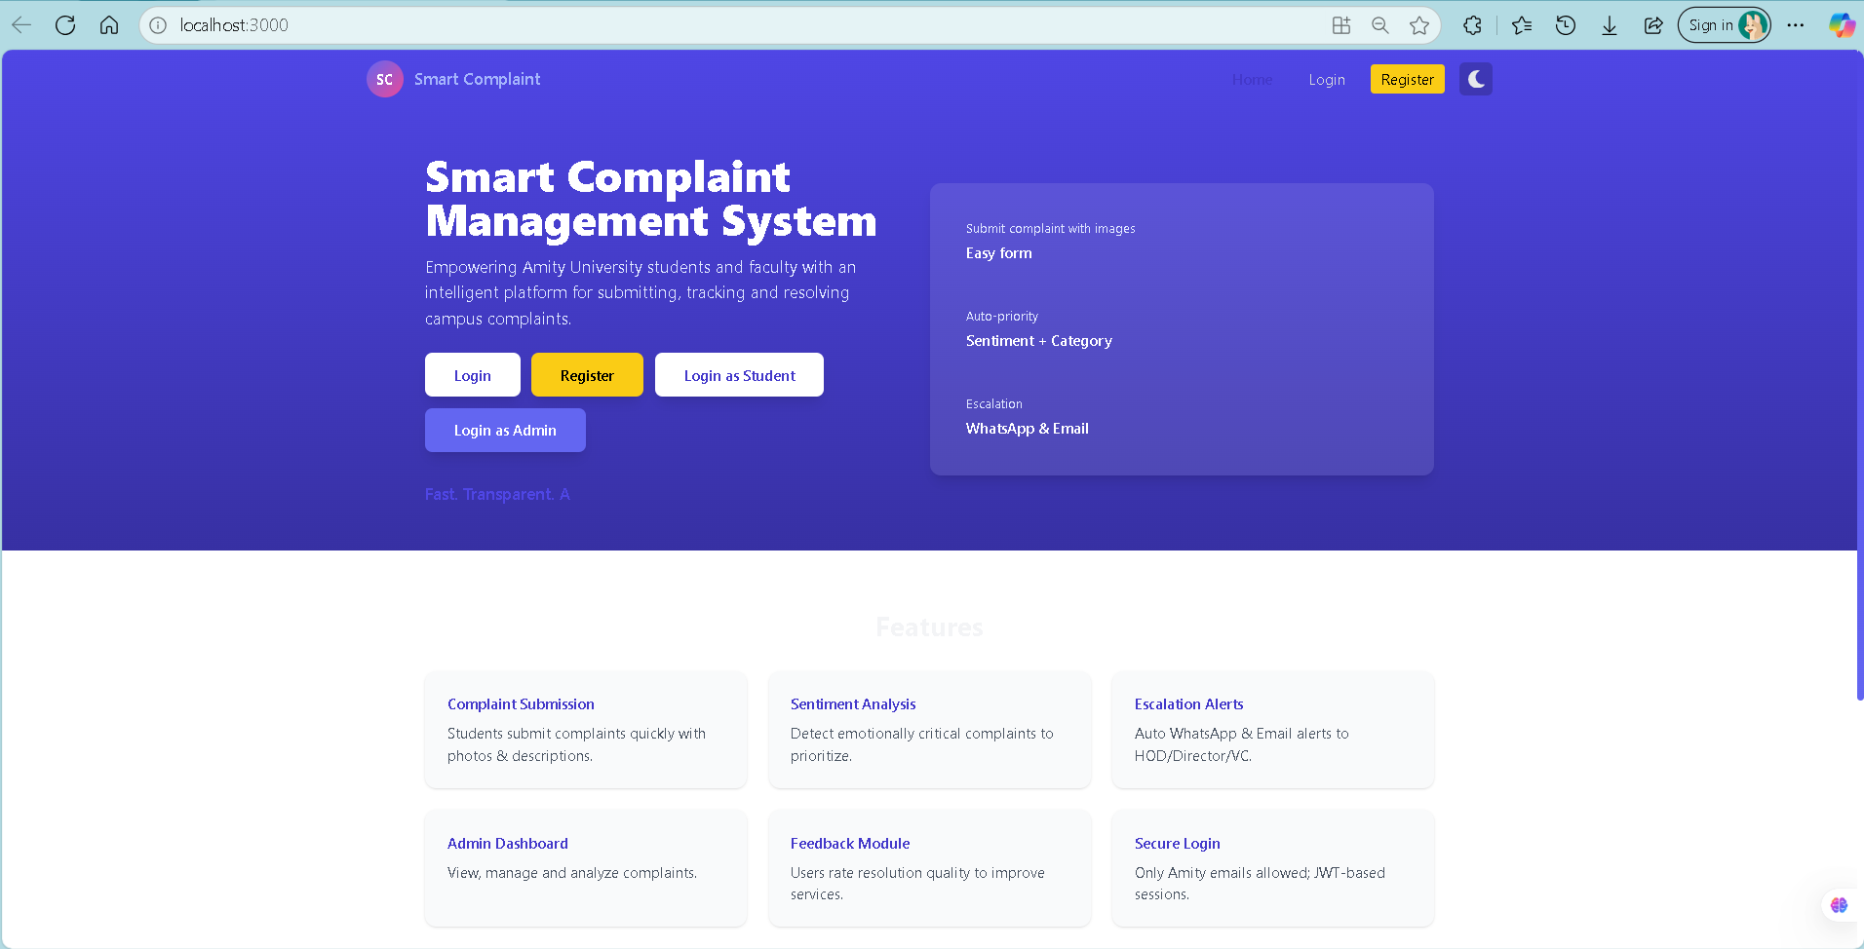

Fig: 3.1 Home Page

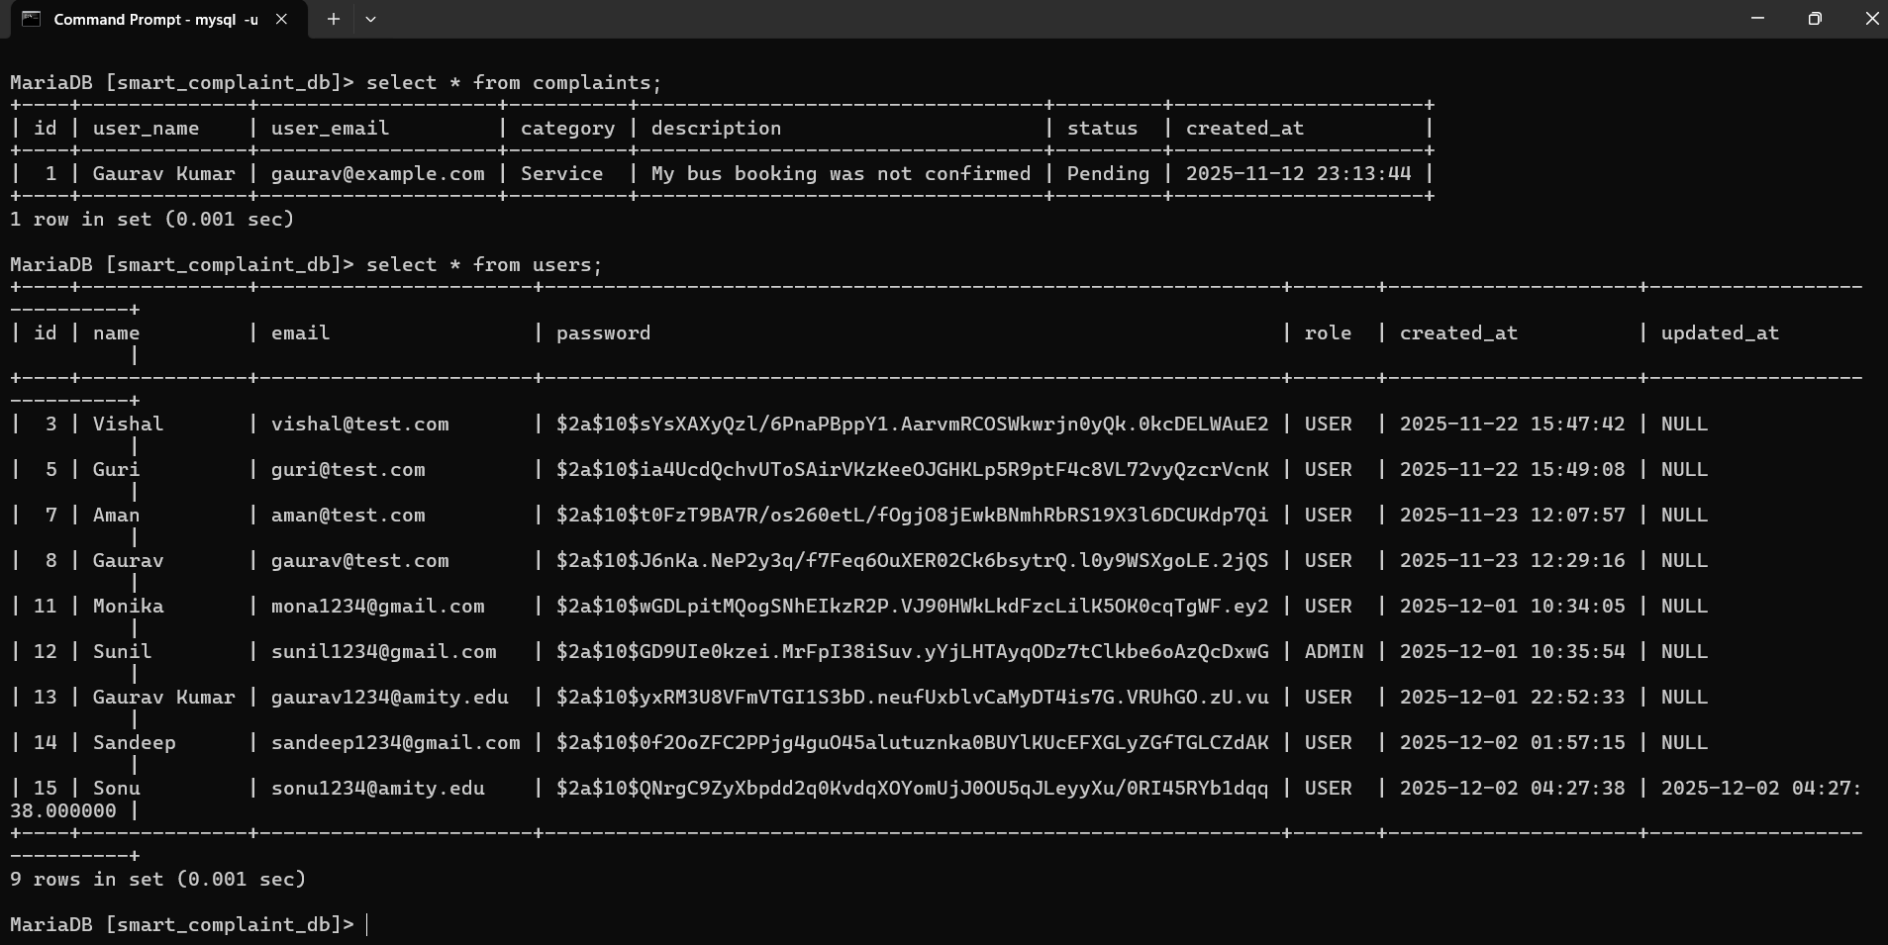

Fig: 3.2 Database

27
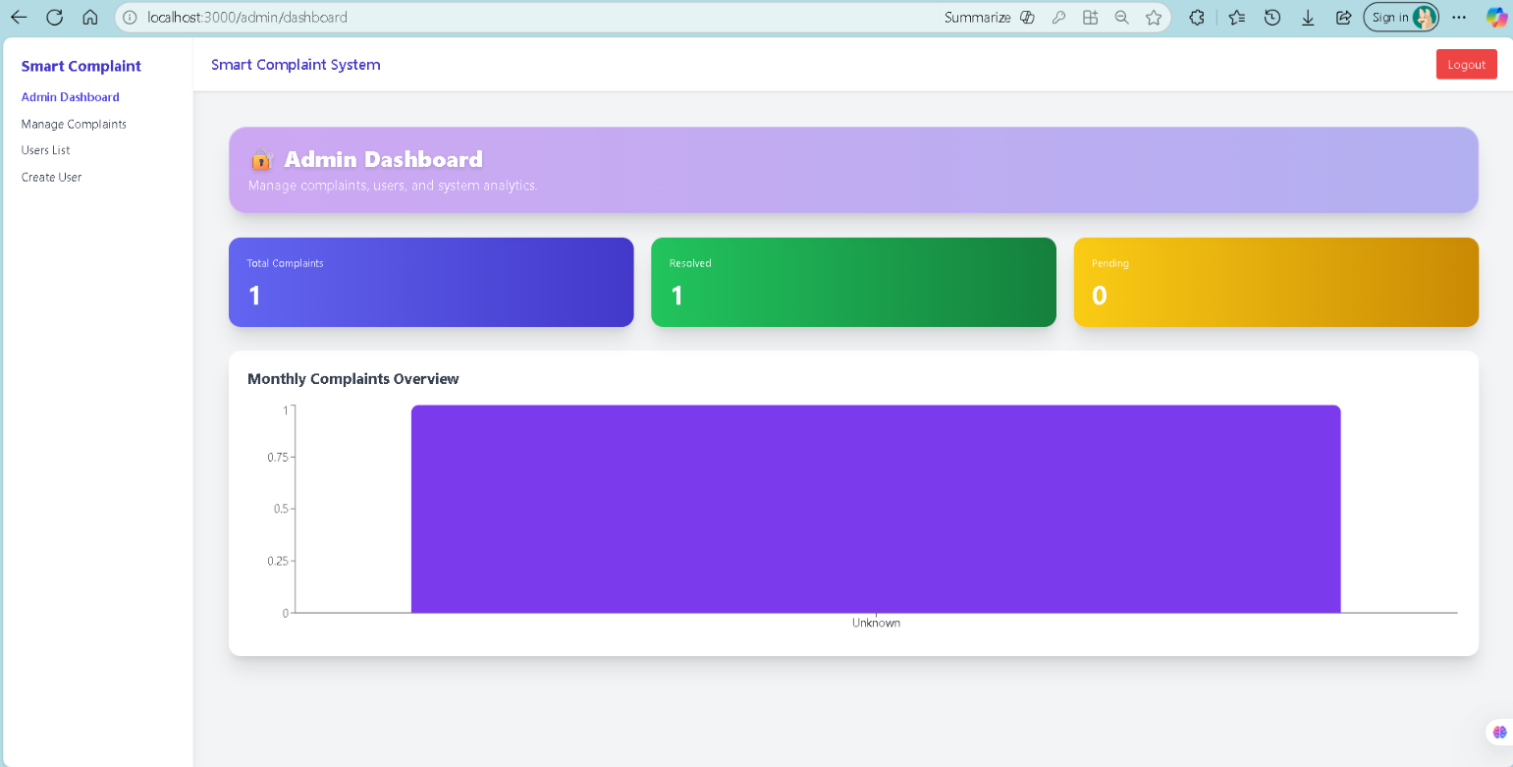

Fig: 3.3 Admin Dashboard.

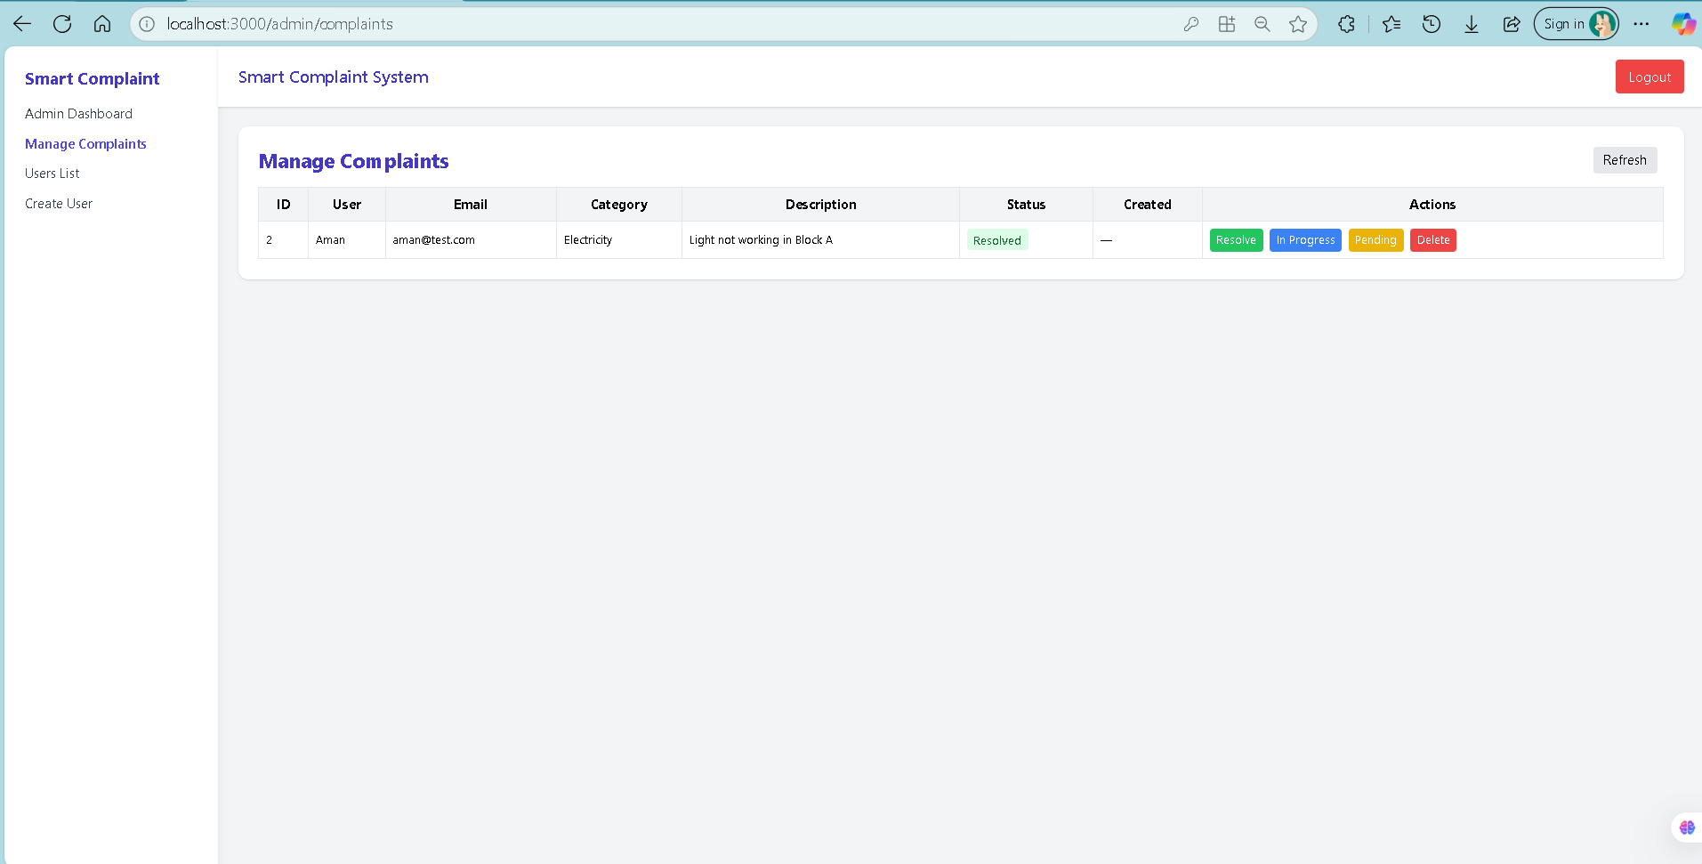
Fig: 3.4 Manage Complaints Dashboard.

28

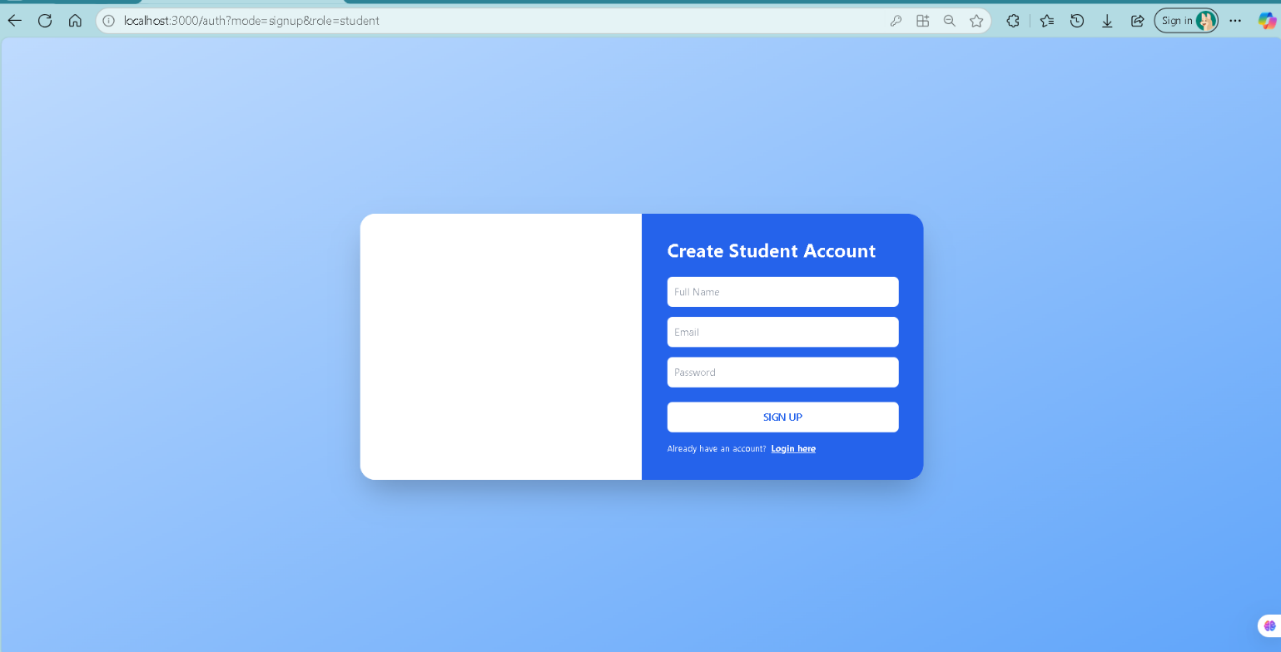

Fig 3.5 Registration page of student.

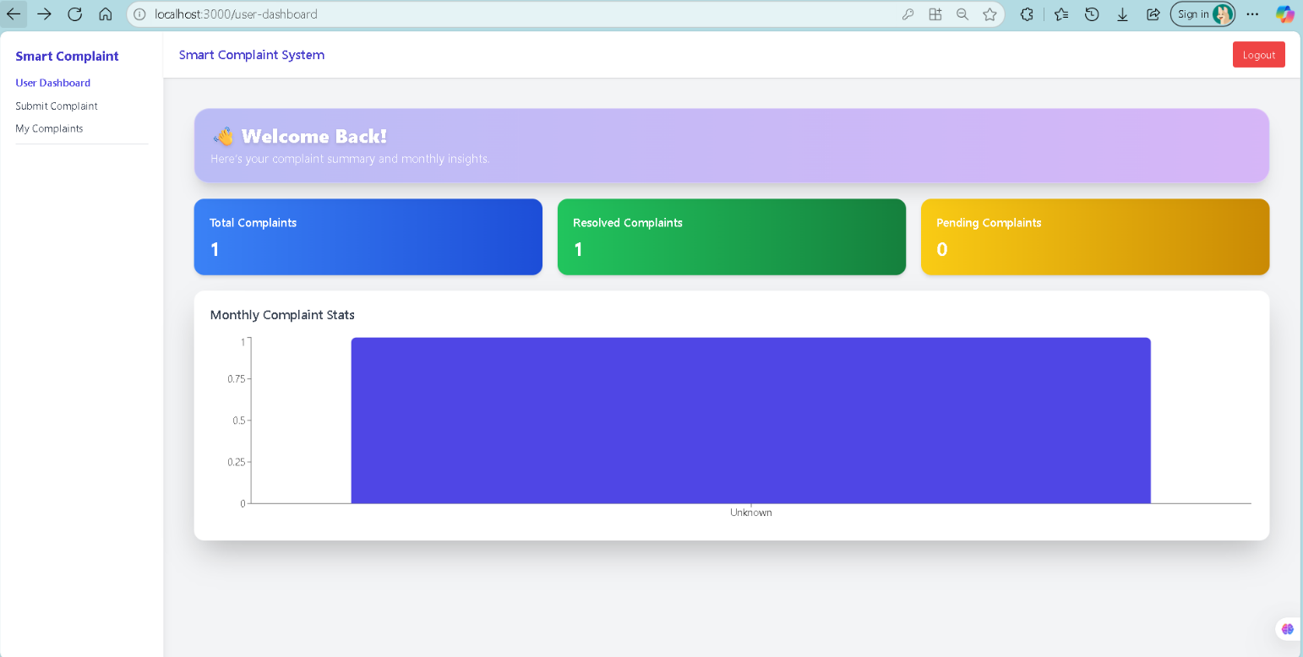

Fig: 3.6 User Dashboard.

29

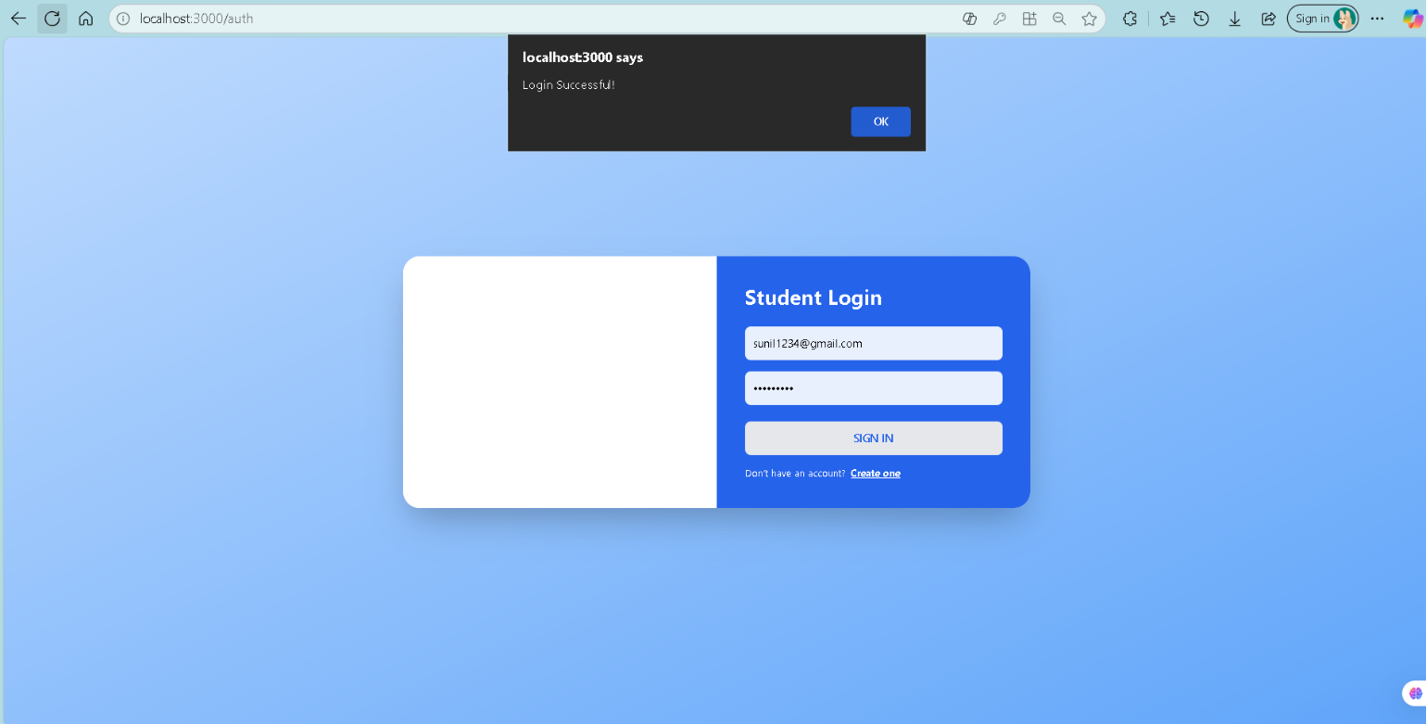
Fig: 3.7 Student Login page.

30

Conclusion

The AI-Powered Smart Complaint Management System with Sentiment Analysis successfully fulfills its objective of providing a modern, intelligent, and transparent platform for managing student grievances within academic institutions. By integrating NLP-based sentiment analysis, a structured complaint workflow, and role-based dashboards, the system significantly improves the speed, accuracy, and efficiency of complaint handling compared to traditional manual methods.
The platform offers a user-friendly environment where students can easily submit complaints and track their status in real time. The inclusion of sentiment analysis allows the system to automatically determine the emotional tone and urgency of each complaint, enabling administrators to prioritize cases effectively and respond more promptly to critical issues. This enhances fairness, reduces delays, and improves institutional responsiveness.
Administrators benefit from centralized complaint management, graphical analytics, category-wise trends, and clear visibility of pending and resolved cases. The automated workflow reduces manual workload, minimizes errors, and strengthens communication between students and administrative bodies. The system’s secure architecture—featuring JWT-based authentication, encrypted data storage, and protected endpoints—ensures privacy, reliability, and safe handling of sensitive information.
Overall, the project demonstrates the feasibility and effectiveness of using AI-enhanced tools to improve grievance redressal mechanisms in educational environments. The system lays a strong foundation for future enhancements such as multi-department routing, chatbot-based assistance, advanced analytics, and integration with institutional ERP systems. By digitizing and automating the complaint management process, the system contributes to a more transparent, efficient, and student-friendly campus ecosystem.

31

References
- [1] “Spring Boot Documentation,” Spring.io, 2024. [Online]. Available: https://spring.io/projects/spring-boot
- [2] “Java Platform Standard Edition Documentation,” Oracle, 2024. [Online]. Available: https://docs.oracle.com/javase/
- [3] “MySQL 8.0 Reference Manual,” Oracle Corporation, 2024. [Online]. Available: https://dev.mysql.com/doc/
- [4] “React.js Official Documentation,” Meta Open Source, 2024. [Online]. Available: https://react.dev
- [5] “TypeScript Handbook,” Microsoft Docs, 2024. [Online]. Available: https://www.typescriptlang.org/docs/
- [6] “Tailwind CSS Documentation,” Tailwind Labs, 2024. [Online]. Available: https://tailwindcss.com/docs
- [7] “JSON Web Tokens (JWT) Introduction,” Auth0 Inc., 2024. [Online]. Available: https://jwt.io/introduction
- [8] “Axios HTTP Client Documentation,” Axios Contributors, 2024. [Online]. Available: https://axios-http.com
- [9] S. Bird, E. Klein, and E. Loper, Natural Language Processing with Python, O’Reilly Media, 2021.
- [10] “VADER Sentiment Analysis Documentation,” Hutto & Gilbert, 2020. [Online]. Available: https://github.com/cjhutto/vaderSentiment
- [11] “Git and GitHub Documentation,” Git SCM and GitHub Inc., 2024. [Online]. Available: https://git-scm.com/doc
- [12] R. Pressman and B. Maxim, Software Engineering: A Practitioner’s Approach, 9th ed., McGraw-Hill, 2020.

32

